Q1

1. ORL Database

Results for eig function

K=1 => 0.0313

K=2 => 0.1953

K=3 => 0.4766

K=5 => 0.75

K=10 =>0.9609

K=15 => 0.9531

K=20 =>0.9609

K=30 => 0.9453

K=50 => 0.9609

K=75 => 0.9453

K=100 => 0.9453

K=150 => 0.9531

K=170 => 0.9531

Exactly same results were obtained for svds function too.

The plot is as follows:

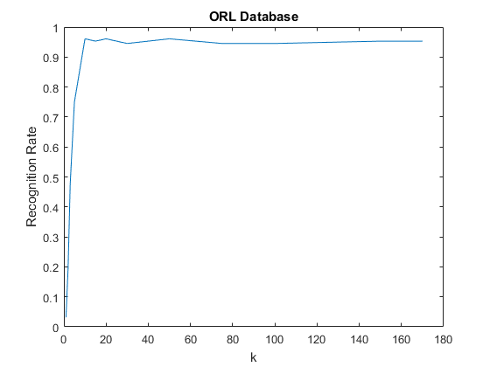

1. Yale Database

K=1 =>0.0263

K=2 => 0.0263

K=3 => 0.0307

K=5 => 0.0570

K=10 => 0.1480

K=15 =>0.1798

K=20 => 0.2039

K=30 =>0.2456

K=50 => 0.2763

K=60 => 0.2873

K=65 => 0.2895

K=75 =>0.2982

K=100 =>0.3081

K=200 => 0.3300

K=300 => 0.3366

K=500 => 0.3399

K=1000 =>0.3410

The plot is as follows (including top 3 eigenvalues)

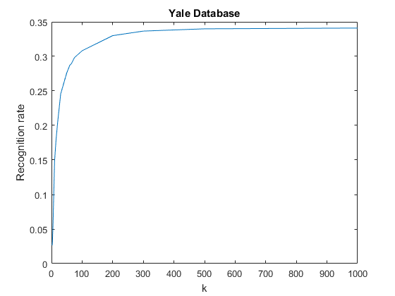

1. Excluding the top 3 eigenvalues, we get

K=1 => 0.0461

K=2 =>0.0461

K=3 => 0.0603

K=5 => 0.1009

K=10 => 0.2555

K=15 => 0.3246

K=20 =>0.3838

K=30 => 0.4397

K=50 =>0.4923

K=60 => 0.5241

K=65 => 0.5274

K=75 => 0.5395

K=100 =>0.5614

K=200 =>0.5899

K=300 => 0.5954

K=500 => 0.5976

K=1000 => 0.5976

The plot is as follows:

